2025 Book Discussions
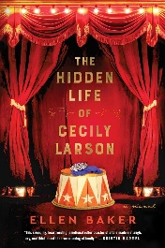
The Hidden Life of Cecily Larson by Ellen Baker
At seven, Cecily is sold to a circus, where she grows up alongside performer Isabelle and later falls for a young roustabout. By 2015, 94-year-old Cecily lives quietly in Minnesota, but a family DNA test uncovers the tragic love story she kept secret for decades.
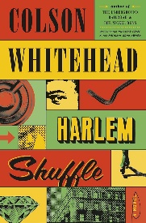
Feb. 11
Harlem Shuffle by Colson Whitehead
Ray Carney is a respectable furniture salesman in Harlem, but his façade hides ties to a family of crooks, with cracks growing as money gets tight. When his cousin Freddie ropes him into fencing goods for a heist gone wrong, Ray is thrust into a world of corrupt cops, gangsters, and lowlifes.
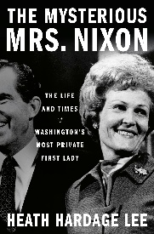
March 11
The Mysterious Mrs. Nixon by Heath Hardage Lee
Pat Nixon, seen as enigmatic, was an admired and active First Lady. She traveled to 83 countries, contributed to key diplomatic efforts, and expanded White House preservation. A strong advocate for women’s rights, she supported the Equal Rights Amendment and women’s reproductive rights
Apr. 8
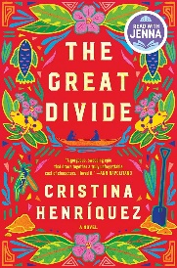
The Great Divide by Cristina Henríquez
Omar, a local Panamanian, seeks connection by working as a digger in the Panama Canal project, to the dismay of his fisherman father. Ada, a determined teenager from Barbados, arrives in Panama to find work and help her sick sister, and when she aids Omar after a collapse, their lives become intertwined.
May 13

The Fury by Alex Michaelides
Lana Farrar, a reclusive former movie star, invites her friends to her private Greek island for Easter. What begins as a getaway turns into a murder mystery when the group becomes trapped, old resentments resurface, and someone is killed. As secrets and grudges unravel, the tension builds into a deadly game of wits, leaving one person dead by the end of the night.
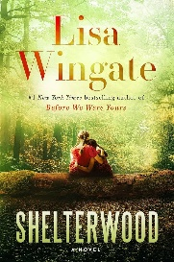
June 10
Shelterwood by Lisa Wingate
In this emotional and enveloping novel, Lisa Wingate traces the story of children abandoned by the law and the battle to see justice done. Amid times of deep conflict over who owns the land and its riches, Ollie and Val traverse the rugged and beautiful terrain, each leaving behind one life in search of another.
July 8

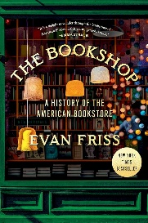
The Bookshop: A History of the American Bookstore by Evan Friss
This book traces the evolution of bookshops from Benjamin Franklin’s first store in Philadelphia to iconic sellers like the Strand and Amazon, illustrating how these spaces shaped communities while becoming endangered institutions.
Aug. 12
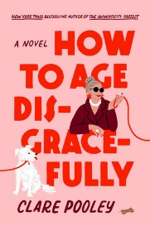
How to Age Disgracefully by Clare Pooley
When Lydia takes a job running the Senior Citizens’ Social Club, she assumes she’ll be spending her time drinking tea and playing gentle games of cards. When the city council threatens to sell the community center building, they join forces with their tiny friends in the daycare next door to save the building.
Sep. 9
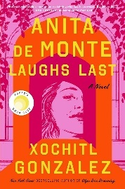
Anita de Monte Laughs Last by Xochitl Gonzalez
Surrounded by students whose futures are already paved out for them, Raquel feels like an outsider. Students of color are pressured to work twice as hard for the same opportunities. As she attempts to straddle two worlds, she questions her own relationship, which mirrors that of a forgotten artist.
Oct. 14
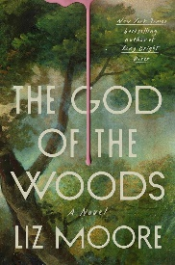
The God of the Woods by Liz Moore
A camp counselor discovers an empty bunk. Barbara Van Laar, has gone missing. She's the daughter of the family that owns the summer camp and employs most of the region’s residents. And this isn’t the first time. Barbara’s older brother similarly vanished fourteen years ago, never to be found.
Nov. 12

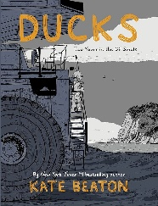
Ducks by Kate Beaton
With the singular goal of paying off her student loans, Katie heads out west to take advantage of Alberta’s oil rush. In doing so, Katie encounters the harsh reality of life in the oil sands.
Dec. 9
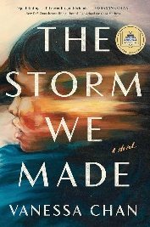
The Storm We Made by Vanessa Chan
Cecily’s family is in danger: her son, Abel, has disappeared, and her daughter, Jasmin, is confined in a basement to prevent being pressed into service at the comfort stations. Her other daughter becomes angrier by the day. Cecily knows two things: that this is her fault; and that her family must never learn the truth.
Jan. 13

Page Turners meet at 10:00 a.m.
Please check www.emporialibrary.org for up-to-date information or contact Molly Chenault at 620-340-6451 or chenaultm@emporialibrary.org.

