2024 Chills and Thrills Book Club
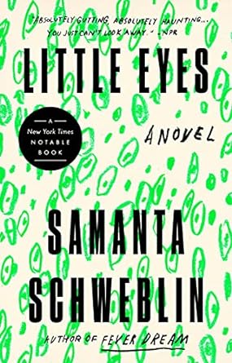
Little Eyes by Samantha Schweblin
They're everywhere. They're here. They're us. They're not pets, or ghosts, or robots. They're real people, but how can a person living in Berlin walk freely through the living room of someone in Sydney?
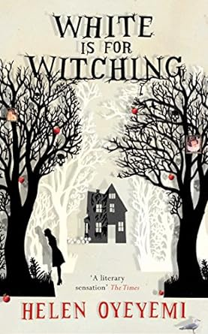
January 19
White is for Witching by Helen Oyeyemi
There’s something strange about the Silver family house in Dover, England. When Miranda’s mother passes away suddenly while on a trip, Miranda begins suffering. When she brings a friend home, Dover’s hostility toward outsiders physically manifests within the four walls of the Silver house.
February 16
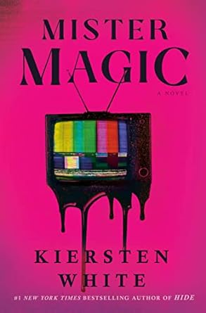
Mister Magic by Kiersten White
Thirty years after a tragic accident shut down production of the children’s program Mister Magic, the five surviving cast members have done their best to move on. Then a twist of fate brings the castmates back together at the remote desert filming compound that feels like it’s been waiting for them all this time.
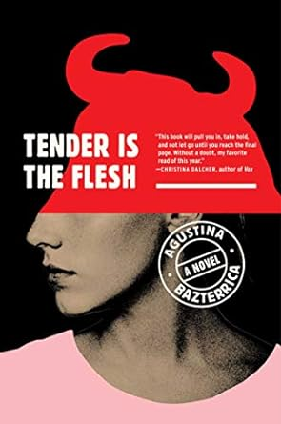
March 15
Tender is the Flesh by Agustina Bazterrica
Eating human meat is legal. Marcos tries to stick to numbers, consignments, processing. Then one day he’s given a gift: a live specimen of the finest quality. Though he’s aware that any form of personal contact is forbidden on pain of death, little by little he starts to treat her like a human being.
April 19
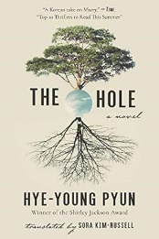
The Hole by Hye-young Pyun
Oghi has woken from a coma after causing a devastating car accident that took his wife's life and left him paralyzed. His caretaker is his mother-in-law. But soon Oghi notices his mother-in-law in the garden, uprooting what his wife had worked so hard to plant and obsessively digging larger and larger holes.
May 17
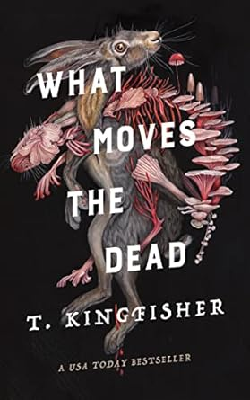
What Moves the Dead by T. Kingfisher
When Alex receives word that their childhood friend Madeline is dying, they race to the ancestral home of the Ushers. What they find there is a nightmare of fungal growths and possessed wildlife. Aided by a British mycologist and an American doctor, Alex must unravel the secret of the House of Usher before it consumes them all.
June 21

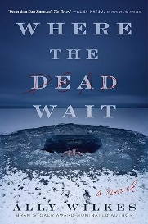
Where the Dead Wait by Ally Wilkes
William Day should be an acclaimed Arctic explorer. But after a failed expedition he returned in disgrace. But when a rescue mission becomes an journey into his past, Day must face up to the things he’s done.
July 19
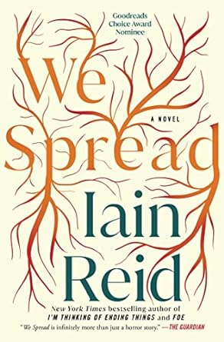
We Spread by Iain Reid
Penny has lived in the same apartment for decades. She is resigned to the mundane rituals of old age, until things start to slip. Years earlier, provisions were made for a room in a long-term care residence. As the days start to blur, Penny starts to lose her grip on the passage of time and on her place in the world.
August 16

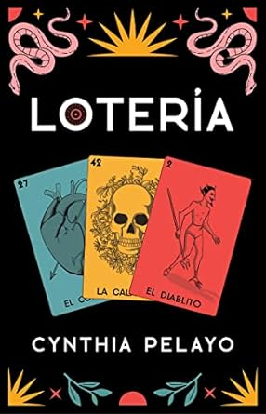
Lotería by Cynthia Pelayo
There are 54 cards in the Lotería game, and for this short story collection you will find one unique story per card based on a Latin American myth, folklore, superstition, or belief—with a slant towards the paranormal and horrific.
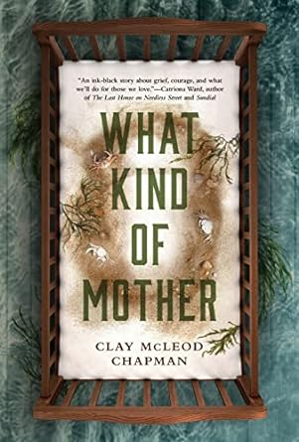
September 20
What Kind of Mother by Clay Mcleod Chapman
After striking out on her own as a teen mom, Madi Price is forced to return to her hometown with her daughter. There that she connects with old high school flame Henry McCabe, now a reclusive local fisherman whose infant son, Skyler, went missing five years ago.
October 18
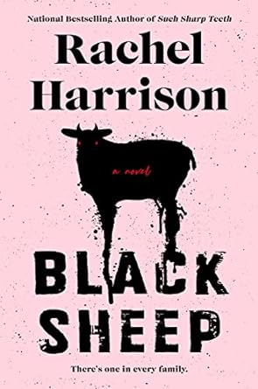
Black Sheep by Rachel Harrison
Vesper left home at eighteen and never looked back. But then an envelope arrives on her doorstep. When Vesper’s homecoming exhumes a terrifying secret, she’s forced to reckon with her family’s beliefs and her own crisis of faith.
November 15
Blink by Christopher Sebela
Wren was three when she was found alone and covered in blood. She’s been haunted by the childhood she can't remember until she finds a cryptic website streaming feeds from strange rooms in a ruined building. Wren breaks in and finds herself lost in the camera-filled dark mazes of a decayed social experiment.
December 20

Please check www.emporialibrary.org for up-to-date information or contact Molly Chenault at 620-340-6451 or chenaultm@emporialibrary.org.

